|  |  |
| --- | --- |
|  | **MINISTRY OF EDUCATION AND TRAINING** |

|  |
| --- |
| **FPT UNIVERSITY** |
| Capstone Project Document |
| [TripNET] |
|  |
| |  |  | | --- | --- | | **<TripNET Group>** | | | **Group Members** | Do Trung Quan – SE02357  Nguyen Hoang Long – SE03685  Nguyen Hoang Long – SE03299  Tran Nhat Linh – SE03795  Dinh Tuan Anh – SE03435 | | **Supervisor** | Mr. Tran Dinh Tri | | **Ext Supervisor** | N/A | | **Capstone Project code** | TripNET | |
|  |

- Hanoi, 09/2017 -

Table of Contents

**CHAPTER 1. INTRODUCTION** 2

**1.1.** **Purpose** 2

**1.2.** **Project Information** 2

**1.3.** **The People** 2

***1.3.1.*** ***Supervisor*** 2

***1.3.2.*** ***Team Members*** 2

**1.4.** **Problem** 3

**1.5.** **Solution** 3

**1.6.** **Compare** **other** **system** 4

**1.7.** **Benefit** 5

**1.8.** **Limitation** 6

**CHAPTER 2 SOFTWARE PROJECT MANAGEMENT PLAN** 7

**2.1. Purpose** 7

**2.2. Problem Organization** 7

***2.2.1. Software Process Model*** 7

***2.2.2. Roles and Responsibilities*** 8

***2.2.3. Tools and Techniques*** 9

**2.3. Project Management Plan** 10

***2.3.1. Task*** 10

**2.3.2. Meeting Minutes** 10

***2.3.3. Coding Conventions*** 11

***2.3.4. Risk Management Plan*** 11

***2.3.5. Communication Plan*** 13

## **CHAPTER 1. INTRODUCTION**

* 1. **Purpose**

This report provides an overview of project include background information, literature review of existing system and raising a proposal for ideas of improvement.

* 1. **Project Information**
* Project Name: **TripNET.**
* Project Code: **TN.**
* Project Group Name: **TripNET Group.**
* Product Type: **Website Application**.
  1. **The People**
     1. ***Supervisor***

|  |  |  |  |
| --- | --- | --- | --- |
|  | **Full name** | **Email** | **Title** |
| Supervisor | Tran Dinh Tri | [tridt@fpt.edu.vn](mailto:trungnt@fpt.edu.vn) | Lecturer |

**Table 1‑1 Supervisor’s information**

* + 1. ***Team Members***

|  |  |  |  |  |  |
| --- | --- | --- | --- | --- | --- |
| **No** | **Full name** | **Student ID** | **Phone Number** | **Email** | **Role in Group** |
| 1 | Do Trung Quan | SE02357 | 0966057359 | [*quandtse02357@fpt.edu.vn*](mailto:quandtse02357@fpt.edu.vn) | Leader |
| 2 | Nguyen Hoang Long | SE03685 | 01683864646 | [*longnhse03685@fpt.edu.vn*](mailto:longnhse03685@fpt.edu.vn) | Member |
| 3 | Nguyen Hoang Long | SE03299 | 01685516681 | [*longnhse03299@fpt.edu.vn*](mailto:longnhse03299@fpt.edu.vn) | Member |
| 4 | Tran Nhat Linh | SE03795 | 0972694289 | [*linhtnse03795@fpt.edu.vn*](mailto:linhtnse03795@fpt.edu.vn) | Member |
| 5 | Dinh Tuan Anh | SE03435 | 0973876107 | [anhdtse03435*@fpt.edu.vn*](mailto:anhdtse03435@fpt.edu.vn) | Member |

**Table 1‑2 Team members’ information**

* 1. **Problem**

Each time you want to travel and discover by yourself, do not following by tours from tourist companies. But you lack of information about your places where you want to go and have many questions in your mind such as “How can I get there?”, “Are there any interesting attractions there?”, “What will I discover there?”, “How much should I budget for the trip?”,… That questions can make you dampen and break your plan.

So a website can provides a lot of information about the trips, shared from many people is an good option for your travel plan.

|  |
| --- |
|  |

* 1. **Solution**

Nowadays, the rapid development of technology has changed our life so much: the way we working, learning, communicate, shopping, entertaining,… and travel is no exception. People tend to booking online tour, hotel and restaurant when they travel.

So after few weeks working together, we decided create a website can solves all above problems, it can provide information that shared from people who did go there before and review their trips. We expect this website to be a community for people who like to travel can share their experience for other.

* 1. **Compare** **other** **system**

In Viet Nam, the website are famous is <https://www.phuot.vn/>. This website has so many topics, the interface of website is complicated. It is hard for guest visit website first time. Beside, member post one topic can show detail about their trip., the information is generic.

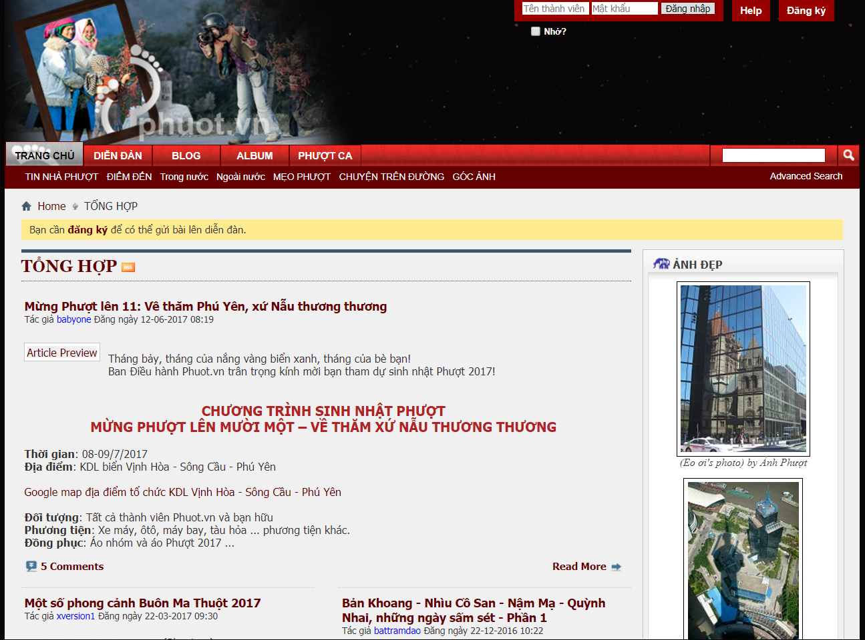

***Figure 1-1 Homepage of phuot.com.vn***

Also have many group share information about travel on Facebook but it very chaotic and make people hard to find and follow the information.

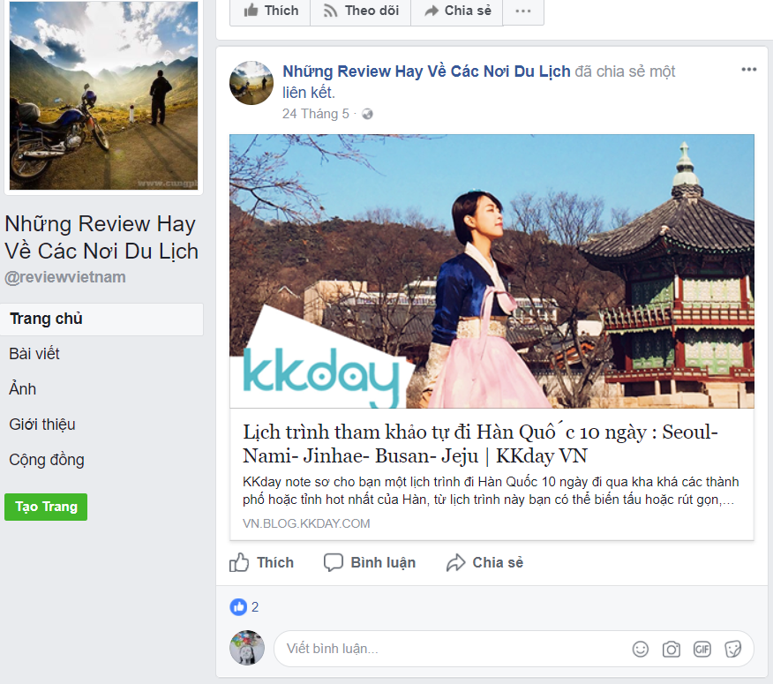

***Figure 1-2 A Travel Group on Facebook***

* 1. **Benefit**
* For our group
* Have change and experiment to develop a project from scratch, how to manage plan, how to promote effective teamwork.
* Training skill about Web Development.
* For guest
* Find the necessary information to prepare their trip in the future.
* Make more friends who are similar interests.
* For member
* Website is a good way to show picture and some special they receive by trip.
* People can express their passion.
* A good member with high rate will receive money from admin from topics what they write.
  1. **Limitation**
* We are not invested.
* We lack of experiment to develop a project.
* Do not understand about business clearly.
* Information depends on user provided.

# **CHAPTER 2 SOFTWARE PROJECT MANAGEMENT PLAN**

## **2.1. Purpose**

The purpose of this chapter is to describe the organization and planning of the project. This chapter describes roles and responsibilities of each member in this project. It also included an overview of this project and team member. This is a document for daily meeting and meeting minute.

## **2.2. Problem Organization**

### ***2.2.1. Software Process Model***

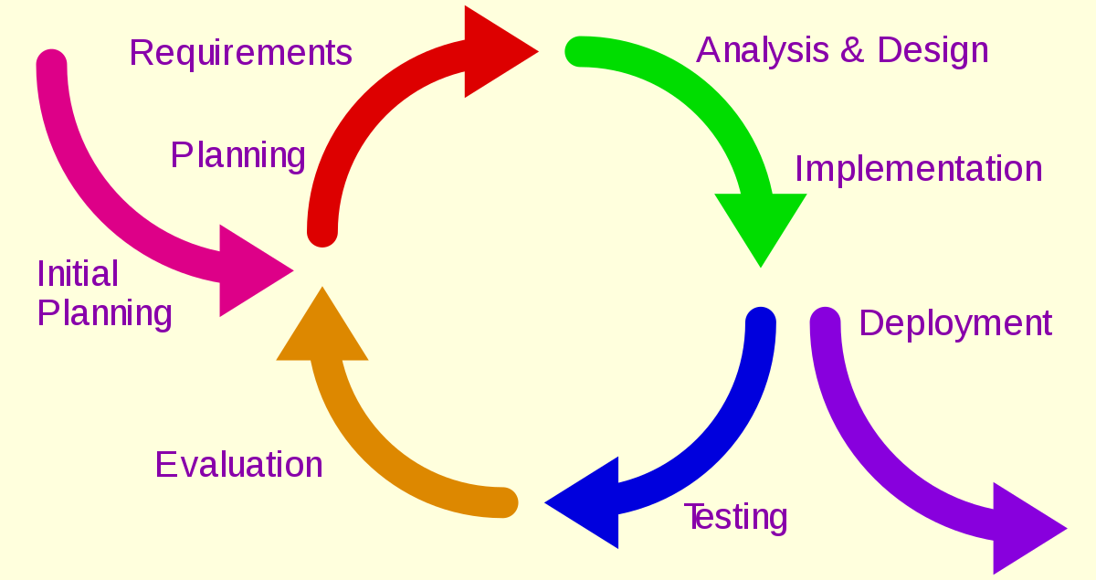

***Figure 2-1 Iterative & Incremental Software Process Model***

The TripNET used “Iterative and Incremental Software Process Model” to develop. This process model is suitable for team and have many advantages:

* We can develop prioritized requirements first.
* Initial product delivery is faster.
* Important functionality can be finish early.
* Requirements changes can be easily accommodated.

### ***2.2.2. Roles and Responsibilities***

***2.2.2.1. Team Organization Structure***

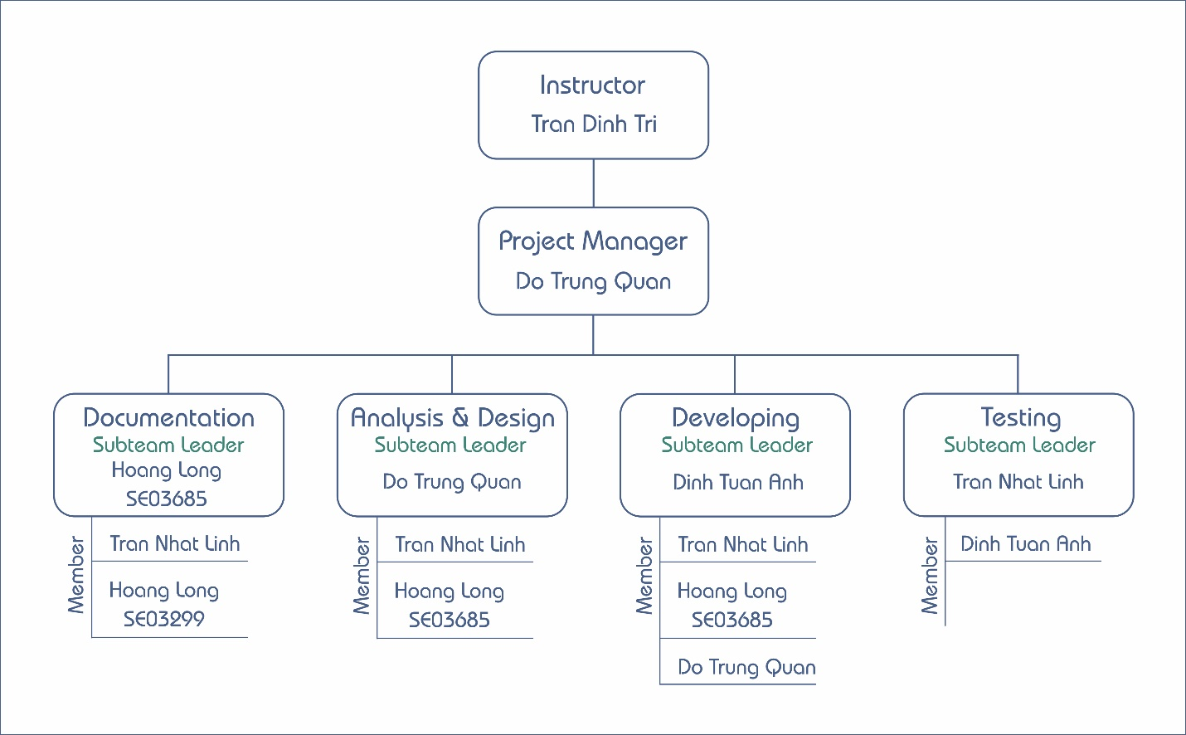

***Figure 2-2 Team Organization Structure***

**2.2.2.2*. Roles and Responsibilities***

|  |  |
| --- | --- |
| **Role** | **Quality Responsibility** |
| Project Management | * Determine scope, plan and resources for project. * Leading the team member, solve conflict in team, keep the team focus on project |
| Documentation Team | * Prepare the all document for project(report, images,..). |
| Analyst & Design Team | * Determine and analyzing requirements for project. * Give solution meet requirements. |
| Developing Team | * Coding functions of project. * Design interface. * Fix bugs(if any) and reviews code. |
| Testing Team | * Defining testing plan and test cases. * Report bugs for Developing team. |

### ***2.2.3. Tools and Techniques***

|  |  |
| --- | --- |
| **Programming Language** | Java, Javascript, HTML, CSS |
| **Framework** | Java Spring, AngularJS, Bootstrap v4.0.0-beta, JQuery |
| **Version Control** | GitHub |
| **IDEs** | IntellJ IDEA, Visual Studio Code |
| **Server** | Tomcat |
| **DBMS** | MySQL 5.6 |
| **UML Tools** | Visual Paradigm, draw.io |
| **Other** | Microsoft Office 2016, Google Drive |

## **2.3. Project Management Plan**

### ***2.3.1. Task***

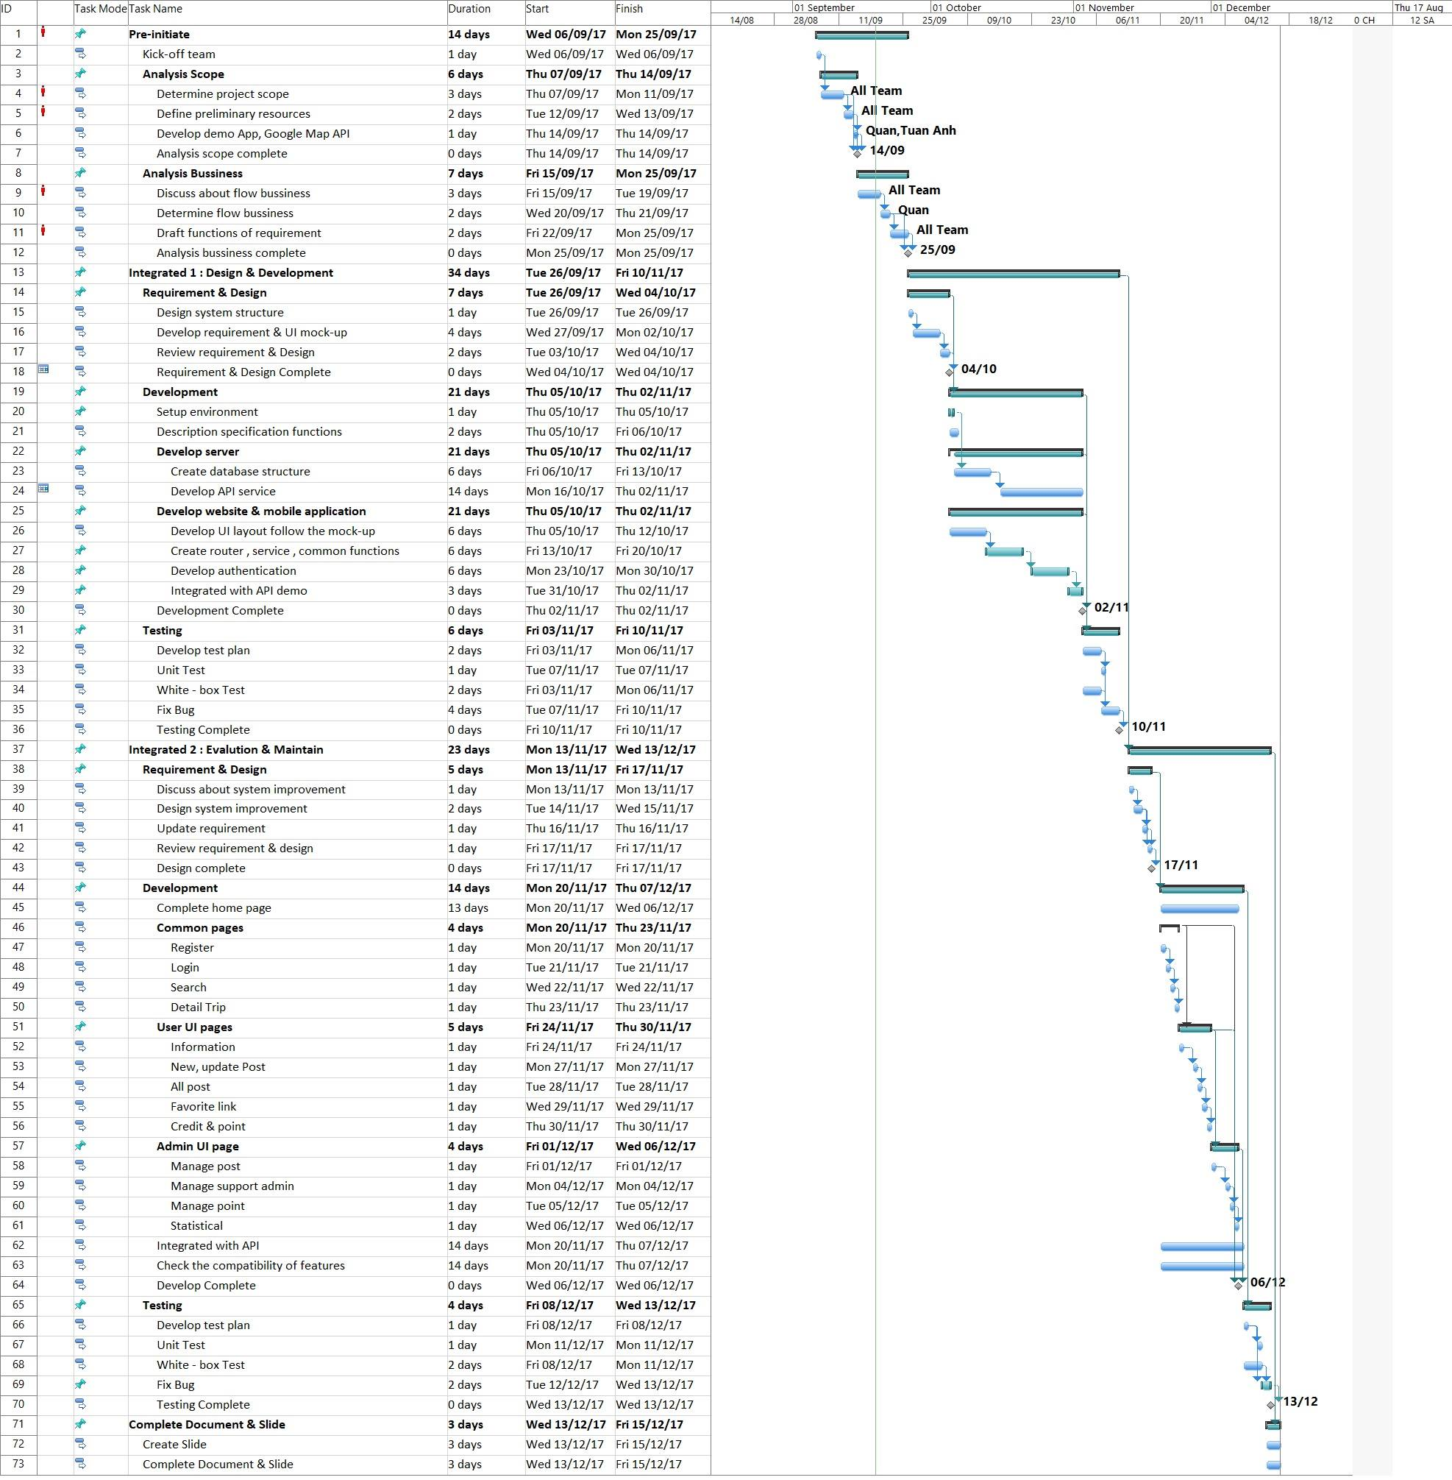

***Figure 2-3 Work Breakdown Structure***

### ***2.3.2. Meeting Minutes***

Weekly meeting is hold on Tuesday every week from 13h30 to 15h00 at room HB/402L FPT University, Hoa Lac Campus.

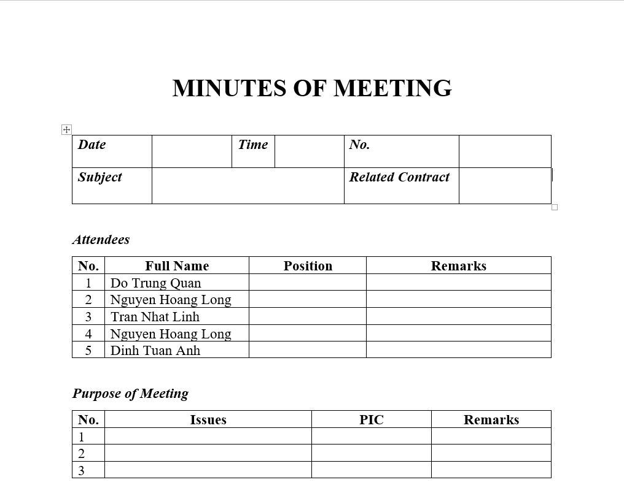

***Figure 2-4 Meeting Minute Template***

### ***2.3.3. Coding Conventions***

* JavaScript coding convention: <https://github.com/airbnb/javascript>.
* Java coding convention: <https://google.github.io/styleguide/javaguide.html>.

### ***2.3.4. Risk Management Plan***

|  |  |  |  |  |
| --- | --- | --- | --- | --- |
| **No.** | **Description** | **Avoidance plan** | **Contingency plan** | **Status** |
| 1 | Conflict between team members | * Holding team building activities to build team to connect team members. * Creating friendly environment. | Talking together to find out problem and solve it as soon as possible. | Close |
| 2 | Absences member | * Providing clearly schedule and place of all meeting to all team members. * Making the rule for team, if member absent many times, PM and other team members should be warning immediately. | Assign tasks to other team members. | Close |
| 3 | Lack technical skills and knowledge | * Training for team members who need know technical skills and knowledge for finish project. * Encourage team members to study for themselves. | Technical leader assists team members personally or in the group to develop required skills and knowledge. | Close |
| 4 | Requirement changes | * Take time to brainstorm features carefully with all team members. * Meticulously design system, take care of all possible situations to avoid changes. | Holding meeting with supervisor to decide which features suitable for implementation. | Close |
| 5 | Losing data | * Backup data daily. * Use tools to management and control source code(Github). | * Restore data from backed up data. * Restore source code from history versions. | Close |
| 6 | Late deadline | Assign suitable tasks for team members depending their abilities, strength and weakness. | * Find the problem and solve it immediately to avoid for the next time. * Assign task to other team member. | Close |

***Table 2‑1 Risk management plan***

### ***2.3.5. Communication Plan***

***2.3.5.1. Project Meetings***

|  |  |  |  |
| --- | --- | --- | --- |
| **Meeting** | **Description purpose** | **Frequency** | **Comments/ Participants** |
| Kick-off meeting | * Project introduction. * Supervisor and team member introduction. | Once, before start project . | Supervisor and all team members. |
| Project requirement meeting | Confirms the project’s requirements. | Once, before developing team start. | All team member. |
| Urgent meeting(optional) | When a serious problems occurs and must be solved immediately. |  | Depends on the problem. |
| Weekly meeting | * Report the progress of last week. * Brainstorming to find out solution for current issues. * Determine the work and assign task for team members for next week. | Weekly, on every Tuesday at 13:30 PM. | Supervisor and all team members. |
| Milestone meeting | * Summarize the result of a development stage. * Implementation plan for the next stage. | After the project has passed a milestone. | Supervisor and all team members. |
| Closing meeting | Summarize the result of project. | After the project finish. | Supervisor and all team members. |

***Table 2‑2 Project meeting***

***2.3.5.2. Communication Methods***

* Face to face: This is most effective and common communication methods.
* Mobile Phone: Used for emergency situation to contact to team members when they are not same place.
* Instant Messages(Facebook Messenger, Skype): Used for general conversation, Skype is used when video calls are required.